Travelling Salesperson Problem – Search with BFS and DFS

Lindie Chenou
[Computer Science & Engineering]
Speed School of Engineering
University of Louisville, USA
lcchen01@louisville.edu

- Introduction (What did you do in this project and why?)
The goal of this project is to calculate the optical cost of visiting each city in a data file. The problem is best known as A Traveling Salesperson Problem (TSP). Compare to the previous project where the program needed to generate the amount to permutation for a given node and find the shortest path from each node to the other; with this project the code needed to implement Bread-First Search and Depth-First Search. For this project, a given set of 11 cities are given. A special case of TSP will be implemented in which not all cities will be connected, also where the program is going to have to calculate the shortest path from starting node 1 to ending node 11.
- Approach (Describe algorithm you are using for this project)
For this project, Python was used to execute the problem. The algorithm expected to be used for this project were the Bread-First search (BFS) and Depth-First Search (DFS). BFS is an algorithm for searching tree or graph data structures that use a queue to find the shortest path from one node to another node. How BFS works is that there are a number of nodes connected where there are a started node and their node to be searched for in the graph. Started node points to one or more nodes that are added to the queue, in which they will. Then the queue nodes will be visited, in which there connecting nodes that have not been visited or adding in the queue will be added in the queue.
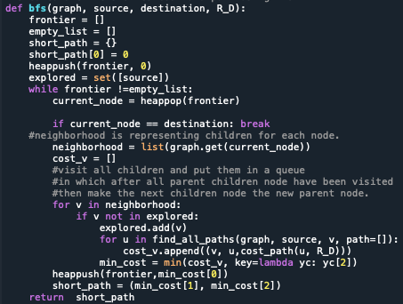
DFS is an algorithm for searching tree or graph in a deathward motion and also uses a stack to find the shortest path from one node to another. Where BFS uses a queue to find the next node to go to, DFS uses the weight between each node to determine which node to traverse to next. From the starting node, the next node will be selected depending on the amount of weight connected with any node attached to that starting node. It will pick the least weight since the algorithm is looking for the shortest path from one node to another.
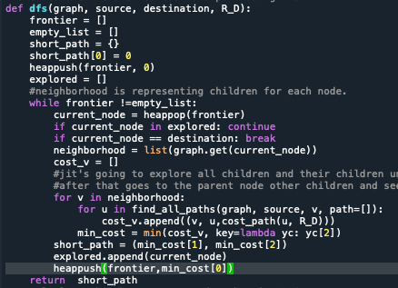
The connection between all 11 cities were also given for this project.
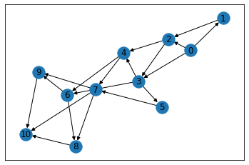
In python, the value starts from 0 instead of 1 reason why the node goes from 0-10. From the picture above, from starting node 0, the shortest path to 10 will be 0-2-4-6-8-10 or 1-3-5-7-9-11 going by scale from 1-11. This picture was generated to see which children come from which parent node.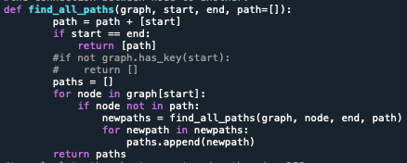
This small algorithm is to help both BFS and DFS to see which children to which parent.
- Results (How well did the algorithm perform?)

  - Data (Describe the data you used.)
A set of cities/nodes and their coordinates where provide. The set contained 11 cities and also provided the connection between each city. The weight between each city wasd calculated by the distance between each city.
  - Results (Numerical results and any figures or tables.)
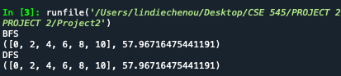

- Discussion (Talk about the results you got and answer any specific questions mentioned in the assignment.)
Between both algorithms, the easiest to code for had to have been DFS. When comparing both algorithms DFS is most of the time faster than BFS. The reason why is because DFS is more efficient when finding a node that is very far away from the starting node. If the file had a smaller number of cities, then BFS would be the more efficient algorithm to run for that particular file. Even though the time complexity is the same for both algorithms (O(V+E)) but it all depends on the size of the file that the program is running.
With the file given having 11 cities, not even programming the code it was expected to have DFS be faster than BFS.
- References (If you used any sources in addition to lectures please include them here.)

https://www.tutorialspoint.com/difference-between-bfs-and-dfs#:~:text=BFS%20is%20slower%20than%20DFS,DFS%20is%20faster%20than%20BFS.&text=Time%20Complexity%20of%20BFS%20%3D%20O,vertices%20and%20E%20is%20edges.

